Project Design Phase-II

Data Flow Diagram & User Stories
Date | 18 February 2026
Team ID | LTVIP2026TMIDS24254
Project Name | Visualization Tool for Electric Vehicle Charge and Range Analysis
Maximum Marks | 4 Marks

Data Flow Diagrams:
A Data Flow Diagram (DFD) is a traditional visual representation of the information flows within a system. A neat and clear DFD can depict the right amount of the system requirement graphically. It shows how data enters and leaves the system, what changes the information, and where data is stored.

Example: DFD Level 0 (Industry Standard)

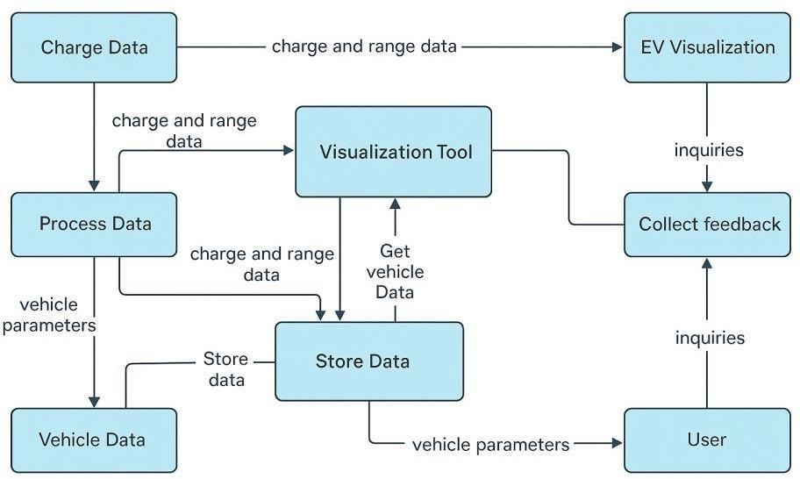
Example: (Simplified)
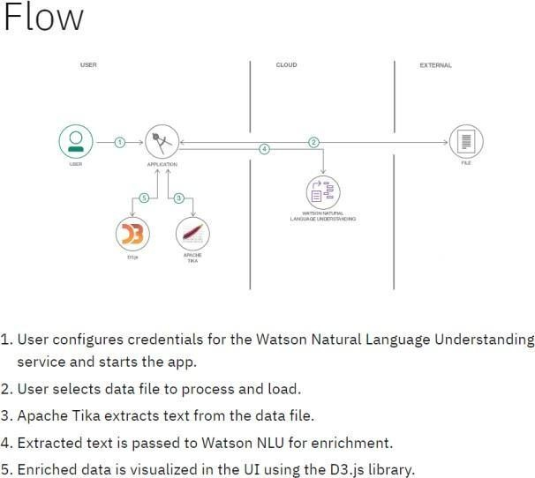

User Stories
Use the below template to list all the user stories for the product.

User Type | Functional  Requirement (Epic) | User Story Number | User Story / Task | Acceptance criteria | Priority | Release
\EV Owner (Mobile user) | Account Management | USN-1 | As an EV user, I want to register and log in to  the app to securely access personalized features | User can create an  account and sign in using valid credentials | High | Sprint-1
 | Map Visualization | USN-2 | As a user, I want to view a map showing nearby charging stations and range zones | Map loads with charging station icons and vehicle  range overlay | High | Sprint-1
 | Vehicle Charge Analysis | USN-3 | As a user, I want to input my vehicle’s battery level and get real-time range estimates | System provides accurate range estimates based on battery and  driving data | Low | Sprint-2
 | Charging History | USN-4 | As a user, I want to view my previous charging sessions and performance reports | App displays historical  charts and statistics about past charges | Medium | Sprint-2
Admin | Data Management | USN-5 | As an admin, I want to upload and manage station data across different locations | Admin panel shows options to  add/update station  information | High | Sprint-1
 | User Monitoring | USN-6 | As an admin, I want to monitor system usage and user activity for improvement tracking | Dashboard reports include session logs and activity summaries | Medium | Sprint-3
Data Analyst | Reporting Module | USN-7 | As an analyst, I want to generate customized reports based on station usage and range patterns | As an analyst, I want to generate customized reports based on station usage and range  patterns | Medium | Sprint-3
Guest User | Demo Access | USN-8 | As a guest, I want to explore the tool in demo mode without signing up | Demo mode provides  limited but working sample visualizations | Low | Sprint-2

